“The A-Files (Alien Files) - Research and Access” ©2020 Jeanie Low

Beginning In 1944, the A-File began with INS (the Immigration and Naturalization Service ) now called the USCIS (US Citizenship and Immigration Service) compiling all documents for each immigrant into the United States in a single file. The A-File is a rich resource that contains all documents pertaining to immigration testimony, rare photos, family history and other federal proceedings for each immigrant. It could contain from 2 to 135 pages. A majority of the documents are in English.The A-Files represent 20th century U.S. immigration and naturalization history and ethnic diversity - of global refugees fleeing war, others seeking economic and/or educational freedom. However, not all immigrants have an A-File. Due to privacy issues, the A-Files are not digitized.

This paper discusses how to research and request copies of A-Files for Chinese who immigrated to the United States beginning in 1944. Some individuals with one hundred birth years entered prior to 1944 during the Chinese Exclusion Act (1882-1943) and were subjected to federal proceedings 30 years after arrival. I use an asterisk * to direct the reader to defined terms in the Notes section at the end of this document.

There could be an A-File for a Chinese American if you know any of the following information. See also https://www.aiisf.org/research :

- The individual entered the U.S. with a “Paper Name”* and underwent the “Confession and Amnesty
Program” * (1955-1965)
- The man or woman who used two different surnames (not a married surname for women)
- There was a surname change for the man.
- The individual became a naturalized* citizen from March 31, 1956 to the present
- The individual was deported
- Immigrated to the United States after April 1, 1944

The following individuals WILL NOT have an A-File and are directed to the USCIS’s Genealogy Program and/or the National Archives (NARA) See sections below:

A. Individual died before 1940
B. Became a naturalized citizen between 9/27/1906 to 8/1/1940. Chinese were not allowed to become naturalized during the Chinese Exclusion Act (1882-1943)
C. Became a naturalized citizen between 8/1/1940 to 3/31/1956
D. Registered as an alien in 1940 without any further action with the Immigration and Naturalization Service.
E. Used a true name during the Chinese Exclusion Act (CEA 1882-1943) . See the National Archives section below.
F. Used a “Paper Name” and did not participate in the “Confesion & Amnesty” Program. See the National Archives section below
G. Became a naturalized citizen after serving in the military and was honorably
discharged. See #8 below

Worksheet to request an A-File, you will need to submit information about each individual. Check if there are any immigration and/or naturalization documents available from family. Is there a box under a bed or documents in a security box? If those documents are not available, complete the steps below to collect information you need to request the A-File. Some A-Files are easily located depending on several factors as outlined below. Have patience, be persistent, keep records and be organized in your research. The A-Files for Chinese are particularly rich textural files for those during the CEA, and you begin to understand the sacrifices your ancestors may have made to become Americans. Fill out a sheet for each person:

- The individual was an immigrant who entered the US before 1965? If yes, when and last residence: __________________________ after 1965, year and where ?_________________________________

- Date of birth _____________

- Entered as a “Paper Son or Paper Daughter *? ______If yes, what name(s)? ________________________________________________________________________________

- Did the individual have two surnames? For example, the Chinese surname character doesn’t match the English transliterated* surname (for women, it does not include the husband’s surname) and may be seen on some gravestones and documents ________________________________________________________________

- Person and/or spouse participated in the “Confession & Amnesty Program* (CAP)” from 1955 to 1965 and cleared their status, name and reclaimed their family history ? _________________________________________________________________________________

- If a person did not participate in CAP. What immigration and/or American name was used?
_________________________________________________________________________________

- Person was a naturalized citizen*? No? If yes, what year and resident state? Name?
_______________________________________________________________________________

- An alien was honorably discharged after serving in the U.S. Armed Forces overseas during WW2 and became a naturalized citizen* ?______Year?____________discharge location________________________________________
1 page. Request a Records Search. Fee is charged: https://genealogy.uscis.dhs.gov/
https://www.uscis.gov/history-and-genealogy/genealogy/historical-record-series/certificate-series-numbers.

- If you have a copy of the Certificate of Naturalization, the A-File # (Alien Registration Number) is found on the upper right edge and begins with the letter “A” followed by numbers “Axxxxxxxx”.
[If you don’t have the Alien Registration Number, birth date, last address, date of admission,
search https://www/ancestry.com/cs/nara under Individual’s naturalization name in Ancestry’s database under the Immigration and Naturalization section.]

Request the A-File for 100 Year Birth Years Transferred to NARA.Kansas City and NARA.San Francisco (National Archives Records and Administration)

Beginning in 2009, A-Files (for individual’s birth year is 100 year old and older) previously under the jurisdiction of US Citizenship and Immigration Service began transferring to NARA.Kansas City ( and NARA.San Francisco for their historic permanent collections and accessible. The person used a “Paper Name,”* underwent the “Confession & Amnesty Program”* (CAP), became a naturalized U.S. citizen, was deported and/or was a regular entry.

Search : NARA. Kansas City and NARA.San Francisco : https://catalog.archives.gov

NARA.Kansascity: The Chinese individual resided in the U.S. (Exceptions : CA, HI, Reno, American Samoa, see NARA.San Francisco.) (July, 2020: NARA.KC has A-Files to 1918 birth years with the names listed in the archives catalog.)

NARA.San Francisco : The Chinese individual resided in California, Reno, NV., Hawaii, and American Samoa. (July, 2020. NARA.SF has A Files for those born 1915 and earlier birth years. The names have not yet been entered. Email them to search its internal database.)

- Type in the person’s Alien Registration Number aka A-File Number (Axxxxxxxx) that is found in the upper right hand corner of the Certificate of Naturalization OR search by the naturalized U.S. citizenship name ie.”(Benjamin Liu A-File) .

- Sample Certificate of Naturalization showing the Alien Registration Number : Leon W. Chooey A14679954 , a partial image - (Leon was born in 1915, entered the U.S. in 1931 and was a naturalized citizen in 1974)

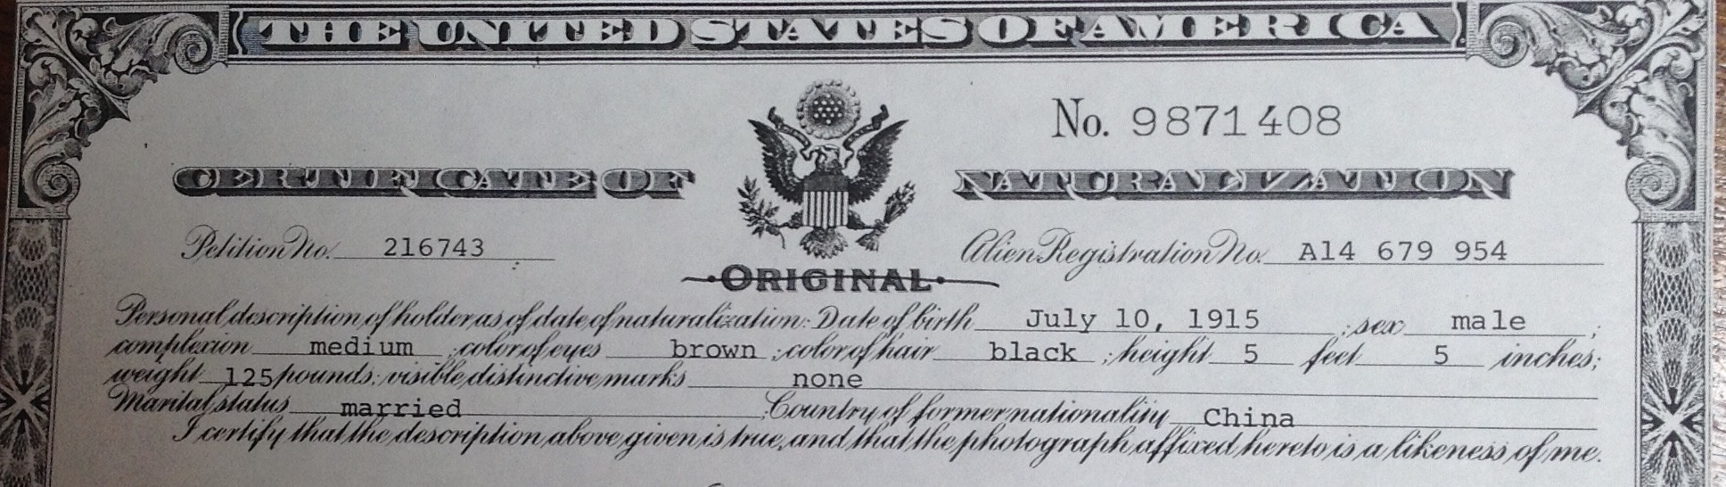

- If you don’t have a copy of the Certificate of Naturalization and need to search for the Alien Registration Number see #9 above.
- Sample NARA search by A File #: A13715252 for Harold Choy - (Harold was born in 1896, entered the U.S. in 1914 and became naturalized citizen in 1964)
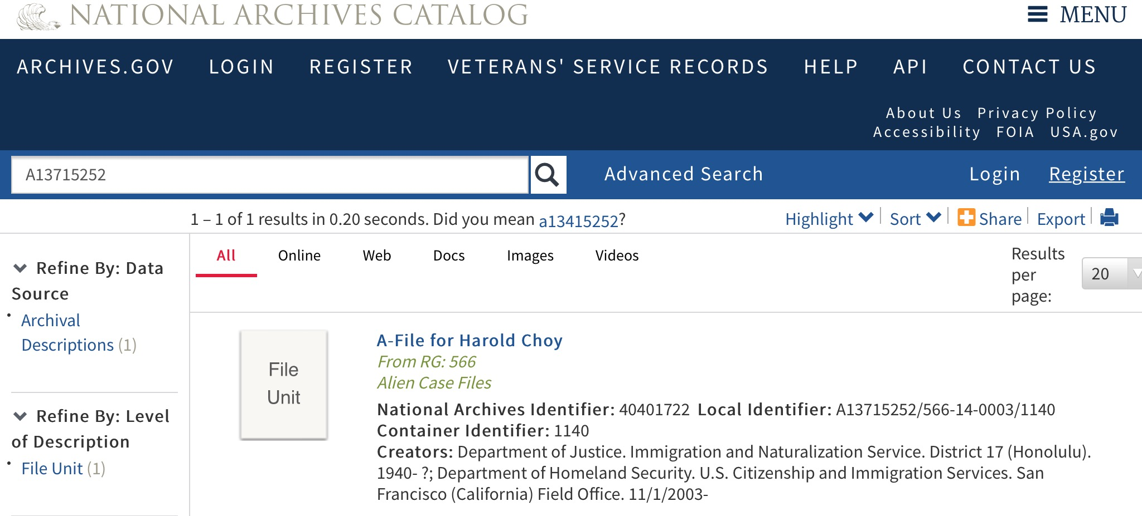

- Sample NARA search by individual’s naturalized name ie. Harold Choy A File
- The A- File index will not be listed by the “Paper Name”* (unless there wasn’t a name change).

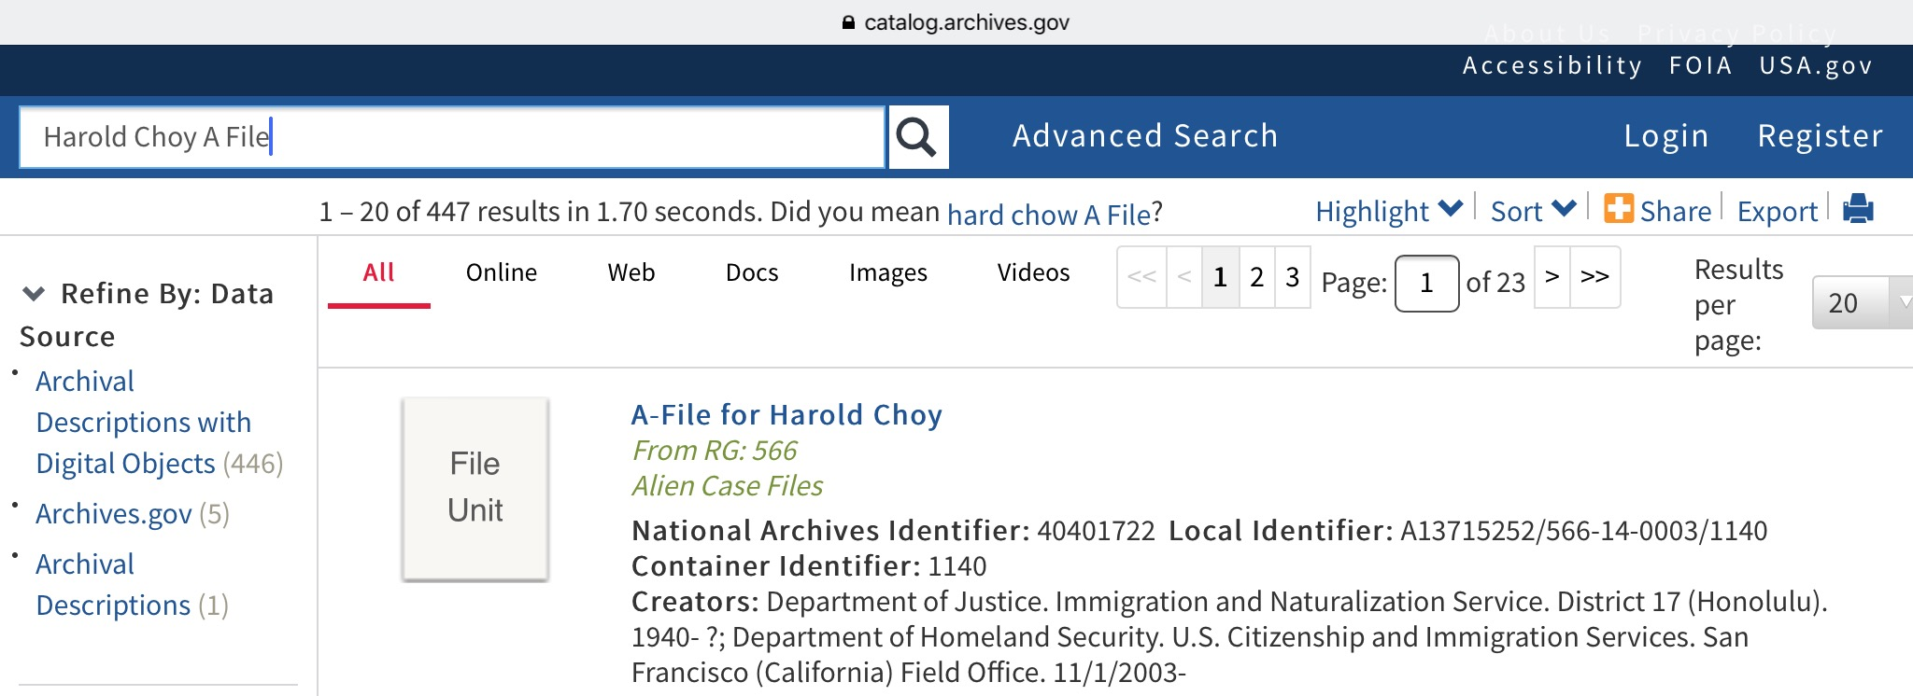

- Click the highlighted name on the Search screen to bring up a detailed description and A File location. You need the following information to request the file:

A. The person’s name
B. National Archives Identifier,
C. Local A- File Identifier Number
D. Accession Number and Box Number.
E. It would also help in providing a date of birth.
F. Fees may apply. Contact for copies or for an in person appointment to review the A-File : AfilesKansasCity@nara.gov or Sanbruno.archives@nara.gov

- 7/2020:Both NARA facilities are accepting email inquiries offsite while both facilities are closed during COV19.. Records retrieval will not be done until the facilities reopen. For birth years 1919 onwards for nationwide residents, see USCIS below).

Individual Used a “Paper Name”* and Did Not Undergo the “Confession and Amnesty Program” (Entries 1884-1944)

This is a RG85 immigration case file and is NOT an A- File. (Though, there may be a document that identifies the individual in a spouse’s A-File). These RG85 case files could be located at a regional National Archives and Records Administration (NARA) in the state the immigrant arrived. However, if the person left the U.S. with multiple re-entries, consult with a NARA Archivist. True information would be his/her photo, arrival date and immigration station, travel dates and vessel. Other family information may not be true if “papers” were purchased from an unrelated family. The Reference Sheet in the case file lists all witnesses and may list true family members if they were witnesses.

Search:
- Locate the closest regional National Archives to the entry port:(www.archives.gov).

- Use the immigration name (the Paper Name) ie.”Seto Bing” and not under the Americanized name like “Frank Seto.”

- 7/10/2020: Email the regional NARA to check if it is responding to email inquiries offsite while its facility is closed during COV19. Records retrieval will be done when the facility reopens.

True Name Individual (Entries 1884-1944)

This is a RG85 immigration case file and is NOT an A- File. The RG85 case file will be rich in documents, photos, and family history. It will most likely be located at a regional National Archives and Records Administration (NARA) in the state the immigrant arrived. However, if the person left the U.S. with multiple re-entries, consult with a NARA Archivist. This file may be in a C File, see USCIS. Genealogy Program.

Search:
- Contact one of the 13 regional National Archives.(www.archives.gov and check name

- Use the immigration name (the Paper Name) ie.”Low Fun” rather than under an Americanized name like “Albert Low.”

- NARA.SF has Chinese Arrival RG85 case files 1884 to 1944. Contact : Sanbruno.archives@nara.gov - 7/10/2020:They are accepting email inquiries while the facility is closed during the COV19. Records retrieval will be done when the facility reopens.

Request an A-File from USCIS (US Citizenship and Immigration Service)

There is an online link to request A-Files through the Freedom of Information/Privacy Act Request (FOIA Form G639) for current A-Files and for A-Files not yet transferred to NARA.Kansas City and NARA.S.F. These A-Files are rich textural files still under the custody of USCIS. These A-Files are in a secured facility at Lee’s Summit, Mo. and not accessible to the public. Fill out a FOIA - Form G639 request for each person and keep a copy for your records: https://www.uscis.gov/system/files_force/files/form/g-639.pdf

Request the complete record for family history. If pages are withheld or heavily redacted (for national security or privacy reasons), write an Appeal Letter to USCIS. USCIS should confirm receipt of your FOIA request(s) within 2 weeks. If the A-File is found, staff will pull the folder and make a copy to send it to you. It may take anywhere from three months to one year of your request. There may be a fee.

If the A- File is not found, you may request a search through the USCIS Genealogy Program. They would also search C-Files that are older immigration files used before the A-Files. A fee is charged whether or not any information is found OR see NARA for transferred A- Files.

Other Resources:
Ancestry.com - free access at All NARA research facilities and most public libraries.
https://www/ancestry.com/cs/nara - free 14 day subscription
Angel Island Immigration Station Foundation.https://www.immigrant-voices.aiisf.org. Personal stories of
immigrants to the Pacific Coast
Chao, Sheau-yueh, In Search of Your Asian Roots:Genealogical Research on Chinese Surnames.
Baltimore:Clearfield, 2000.
Familysearch.org - Free searches from home with registration
“A Guide to Records of AsianAmericans & Pacific Islanders at NARA.Pacific Region”. Compiled by Bill
Greene, Bob Glass, and Dan Nealand. National Archives and Records Administration. Reference Paper 111, 2004. Excellent.”
Louie, Emma Woo, Chinese American Names:Tradition and Transition. Jefferson, North
Carolina:MacFarland & Co., 1998.
Low, Jeanie “China Connection:Finding Ancestral Roots for Chinese in America” (out of print) found in
libraries. (jchoolow.3910x@gmail.com) send an email for a complimentary 10 minute consultation on your research.)
NARA.Kansas City, 400 W.Pershing Rd., Kansas City, MO 64108. Attn:A-Files Request or
Afiles.KansasCity@nara.gov
NARA. San Francisco in the Leo J. Ryan Memorial Federal Building, 1000 Commodore Drive. San Bruno,
California 94066-2350 Phone: (650) 238-3501)or Sanbruno.archives@nara.gov
“The Repeal and Legacy:Proceedings of the Conference on the 50th Anniversary of the Repeal of the
Exclusion Acts, Nov. 12-14, 1993.” A Joint Project of the Chinese Historical Society of America and Asian American Studies, San Francisco State University. Brisbane:Chinese Historical Society of America: 1994. (Him Mark Lai’s essay “Unfinished Business:The Confession Program” pp.47-57.) Also See :Him Mark Lai “Unfinished Business: The Confession Program” Download at: https://himmarklai.org/digitized-articles/1991-1995/confession-program/
******************************************************************************************************************************
Notes:
“Ah” Names - Used to identify early miners and laborers pre1900s and are not their surnames. An “Ah” name is used by Chinese as a casual name. The formal name :Wong Yoke Jing, would be “Ah Jing”.

Chinese Exclusion Act (CEA) 1882-1943: Chinese laborers were excluded from immigrating into the U.S. The law allowed entry to Chinese scholars, travellers, diplomats, merchants, laborers ( who entered before 1882) and those with Derivative U.S. Citizenship. The US Supreme Court repealed CEA in 1943 ruling that it was a racially discriminatory law.
“Confession & Amnesty Program” (CAP)- From 1956 to 1965 the government program to investigate Chinese who may have entered the United States using “Paper Names” during the Chinese Exclusion Act. They were threatened with deportation and/or imprisonment. Those who were subjected to the CAP were able to reclaim their names. However, not everyone who used a false identity participated and continued to use the “Paper Surnames” leaving their descendants with confusing family trees.

Derivative citizenship is an individual born outside of the U.S. who is the son or daughter of a Native Born or a naturalized citizen.

A Native Born is a citizen. The U.S. Constitution’s 14th Amendment defines an individual born in the United States and/or was naturalized as a citizen.

A naturalized citizen is a foreigner who immigrated to the U.S.A., established residence status, applied
for citizenship, passed the security check, witness interviews, and passed the naturalization examinations.

“Paper Name aka Paper Son and Paper Daughter” is an assumed identity used by some Chinese immigrants to circumvent the Chinese Exclusion Act (CEA 1882-1943).

“Shee” combined with a surname for a woman such as : “Chan Shee” generally indicates that her maiden name is Chan. Those records are among the most difficult files to research unless their husband’s names are known.

Transliterated surname: The western spelling of a Chinese surname was based on the regional dialect spoken by the Chinese immigrant at the entry port. It is possible to have several spellings of the same surname or similar sounding surnames. Always look at the Chinese character to determine the Chinese surname.

Acknowledgements: Elizabeth Burns, Director. NARA. KC, Stephanie Bayless, Director. NARA.SF., Marisa Louie Lee, Douglas Joe, Jeannie Young,


Jeanie Low, Family History Consultant. She is a second generation Chinese American who speaks limited Kaiping and Cantonese. Jeanie has been a Lecturer on Chinese American Genealogy since 1993 for the various organizations: NARA, National Genealogical Society, California Genealogical Society, Chinese Historical Society of America, San Francisco State University and various public libraries. She has degrees in Library Technology and Chinese Studies. Jeanie is a SONA Communications Co-Chair - Preservation for the A-Files. Author of “China Connection:Finding Ancestral Roots for Chinese in America”. Fiber Artist.

“The A-Files (Alien Files) - Research and Access” ©2020 Jeanie Low jchoolow.3910x@gmail.com

